**2025 Pathway to Water Quality**

**EDUCATION AREA**

**A note to the Volunteers:** Thank you for taking the time to work this shift and educate State Fair Guests about water conservation! You do not need to be an expert in water or soil management to have meaningful conversations about water conservation. Your main role is to be a friendly face with Guests along the Pathway to Water Quality and have fun!

**Activity Descriptions:**

**Pollinator Tic-Tac-Toe**

Summary: An oldie and favorite, this game board can be traced back to ancient Egypt! We have brought it to Pathway to Water Quality, but instead of X vs. O it is Bee vs. Ladybug.

Procedure:

1. This is setup off to the side on the ground and available for all ages to play a game or two.

Volunteer’s Role:

* If you are not busy or if you have another Volunteer with you, you are welcome to partake in a game with any Guest that is looking for an opponent and/or suggest looking under the stumps for insects that live in moist, dark places. *Use of the magnifying glass should ONLY be with your guidance!*

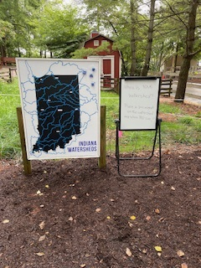**Wooden Watershed Map Puzzle**

Summary: Guests put together the wooden watershed puzzle   
pieces to create the map of Indiana and/or views the watershed  
where the patron lives.

Volunteer’s Role:

* Interact with the guests about Indiana watersheds.

**Suggestions for interactions**:

* *Can you find where you live on the map?*
* *Do all of your family live in the same watershed?*
* *Is this the same watershed where you go to school? Play sports? Etc.*
* *Do you know about low head dam safety?*

**Sounds of Water “Touch Table”: Can you make the sound of a rainstorm?**

Summary: Try to simulate the sounds of water found in Indiana rivers and streams with the instruments OR try to simulate the sounds of a rainstorm using the hydrograph to guide the volume of sound.

Procedure:

1. Participants can try different instruments and suggest what type of water they are simulating.

Examples: “babbling brook”, “rushing river”, “thundering waterfall”, rainfall, etc.

1. Older patrons can try to simulate the sounds of a type of rainstorm by following the hydrograph. The sound should get louder when the rainfall increases and vice versa.
2. Other talking points:
   1. Safety awareness after a large rainstorm around bodies of water and especially around low-head dams (see infographics on the watershed puzzle table).
   2. The importance of water gages in rivers (share the Fall Creek hydrograph) and why paddlers should check the water level BEFORE entering a waterway.
3. Award a sticker or tattoo for patrons who participate.

EXTRA: “Green water” Walter tattoos are available as a teaching tool (or give away)---Ask: Would you rather have green water or blue water? What would cause the water to turn green? (Algal bloom!)

Volunteer’s Role:

* Lay out the instruments and infographics for patrons to use.
* In the event of inclement weather or at the end of the day, please gather the materials and store them in the education barn.

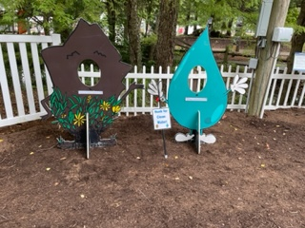**Walter & Sally Photo Op**

Summary: Guests can take a selfie with Pathway to Water Quality’s mascots: Walter Water Drop and Sally Soil.

Volunteer’s Role:

* Take a selfie with Walter Water or Sally Soil to remember your day at Pathway to Water Quality. 😊
* Assist in taking family photos with characters as time and availability allows.
* If it is windy and the characters are falling over, please pack back inside the Education Barn.

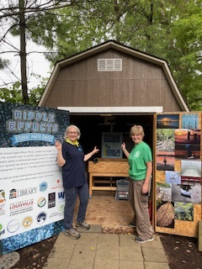**Augmented Reality Sandbox**

Summary: Visitors can shape a landscape in the sandbox and see how a watershed forms.

Procedure:

1. Allow participant to shape a landscape with the sand by standing IN FRONT   
   of the sandbox ONLY.
2. Have the guests wave their hands under the light and watch a watershed form!

NOTE: If the sand is dry, please add water. (Use a watering can found in the history barn.)

Volunteer’s Role:

* Encourage visitors to keep the sand IN the sandbox, but feel free to use the broom and dustpan as needed.
* CAUTION: The cart rolls, so please make sure that visitors use care when creating a landscape. Also, take care not to hit the monitors on the sides! 😊
* If you have any questions, please feel free to call Kathy Madren: 317-409-7916

**TEAR-DOWN:**

Power down everything inside the ed barn. Bring the orange extension cord into the ed barn and close the window.

Please help repack all activities back inside the Education Barn as you are able to and place IN FRONT of the sandbox. Tables, mascots, and chairs will need to lean against a wall towards the front of the barn.

Hang sign across the barn entrance to indicate the area is closed when a volunteer is not in the area.

***Thank you volunteers---you are the BEST*!**

**Sally Soil**

**Walter Water Drop**